**ELECTROMAGNETISM**

Many applications of electricity are based on the fact that electric current passing thru a conductor produces a magnetic field around the conductor or vice versa, i.e. when a conductor moves thru a magnetic field, an electromotive force (emf) is generated and hence current could flow if there is a complete loop. This is called electromagnetism. The operation of such devices or machines like the electric motor, generator, the transformer, the inductor coils, etc. are all based on this phenomenon.

1. ***The Magnetic Field***

It is a region in space wherein a force acts on a charge moving through it.

Ex. The space around a magnet

The space around a current-carrying conductor

One characteristic of a magnetic field is its direction which is usually indicated by a set of lines drawn in the magnetic field called magnetic field lines (also called magnetic lines of force or lines of induction).

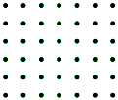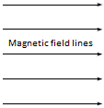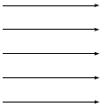

(A uniform magnetic field directed to the right)

(A uniform magnetic field directed to the downward)

(A uniform magnetic field directed out of the plane of the paper i.e. towards the observer)

(A uniform magnetic field directed into the plane of the paper i.e. away from the observer)

Note: When the lines are curved, the magnetic field is non-uniform and the direction at any point is taken by the tangent to a line passing through that point.

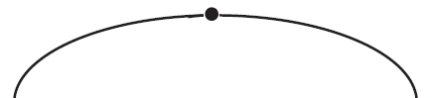

direction at point “P”

P

1. ***Magnetic Flux* (∅)**

A set of magnetic field lines or a group of lines taken or computed as one

Units of Magnetic Flux

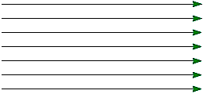

Flux of 7 lines

Flux of 3 lines

Flux of 4 lines

For CGS system

1 Maxwell = 1 line

For MKS system

1 Weber = 108 lines

Ex. ∅ = 5 x 10-4 Weber means

(5 x 10-4)( 108) or 5 x 104 field lines

1. ***Magnetic Flux Density* ($β$)** at a point

Magnetic flux passing per unit area of a surface placed at the point perpendicular to the magnetic field.

 Let **∅** = the flux that passes through area A

**βP** = the flux density at pt “P”

**.**

Area A placed at point “P”

**P**

$β_{P}=\frac{∅}{A}$

if ∅ is in Webers and A in m2

β is in or Tesla (T)

Note: 1. If the surface area *A is PERPENDICULAR to* β then, **∅ = βA**

where θ is the angle between the normal to the surface and β

2. If the surface area *A is NOT PERPENDICULAR to* β then, **∅ = βAcosθ**

Magnetic flux density is a vector quantity and its direction is the same as the direction of the magnetic field at a point.



**βP** (Tangent to a field line passing through the point)

P

SAMPLE PROBLEMS:

1. The figure below is a perspective view of a flat surface with area 3cm2 in a uniform magnetic field. The magnetic flux through this surface is +0.9 mWb. Find the magnitude of the magnetic field.

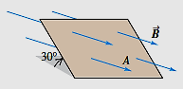

1. Determine the flux that passes through the area as shown on the figure below.

y

2 cm

60O

6 cm

β = 2 Tesla

x

z

**SOURCES OF MAGNETIC FIELD**

1. **MAGNETIC FIELD OF A MOVING CHARGE**

When a charge moves through a portion of space, a magnetic field is created around the charge.

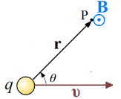

To obtain the magnetic field produced by a charge, q, moving at velocity v, at a point located at a displacement r from charge, we need a mathematical expression the field in terms of ***q***, ***v*** and ***r***.

$$β= \frac{μ_{0}}{4π}∙\frac{\left|q\right|v sinθ}{r^{2}}=1x{10}^{-7}\frac{\left|q\right|v sinθ}{r^{2}}$$

where: β = magnetic field at any point “P” near the moving charge (Tesla or Gauss)

q = electric charge (Coulomb, statcoulomb)

v = speed of the electric charge (m/s, cm/s)

r = distance of the point from the charge

θ = angle between r and v

μ0 = permeability of free space (Permeability is the measure of the ability of a material to support the formation of a magnetic field within itself.)

= 4π x 10-7 T.m/A

***Direction: RIGHT HAND RULE*** Thumb: velocity, v

4 fingers: magnetic field, β

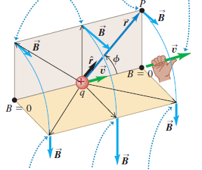

For these field points, ***r*** and ***v*** both lie in the

x-z plane, and ***B*** is perpendicular to this plane.

For these field points, ***r*** and ***v*** both lie in the y-z plane, and ***B*** is perpendicular to this plane.

**Right-hand rule for the magnetic field due to a positive charge moving at constant velocity**

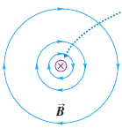

The x symbol indicates that the charge is moving into the plane of the page (away from you).

***NOTE:*** *If the point* ***charge is negative****, the directions of the field and* ***field lines are the opposite*** *with that of positive charge.*

1. **MAGNETIC FIELD at any POINT NEAR a STRAIGHT CONDUCTOR**
2. ***Short Straight Conductor***

The magnetic field due to the electric current in a straight wire is such that the field lines are circles with the wire at the center.

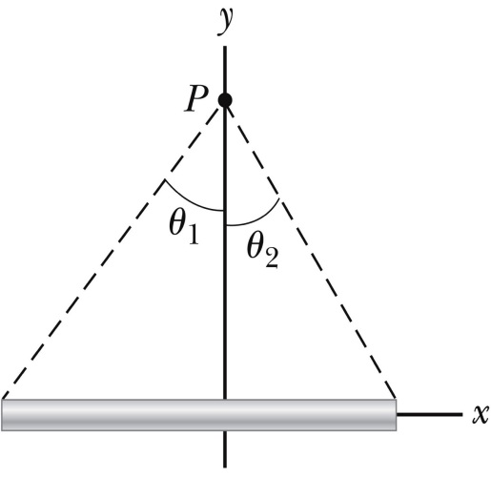

***I***

***r***

$$β_{P}= \frac{μ_{0}}{4π}∙\frac{I}{r}(sinθ_{1}+sinθ_{2})=1x{10}^{-7}\frac{I}{r}(sinθ_{1}+sinθ_{2})$$

Where: βP = magnetic field at a point P away from the conductor

*I* = current through the conductor

r = perpendicular distance between point P and conductor

θ1 & θ2 = angles it make at the point with the conductor

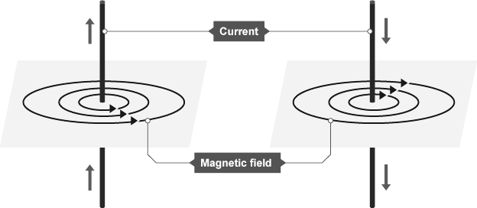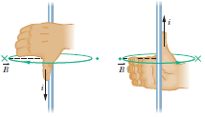

**USING RIGHT HAND RULE:**

Thumb: current, *I*

4 Fingers: magnetic filed, $β$

1. ***Long Straight Conductor***

For infinite/long straight conductor, θ1 & θ2 = 90O and sin(90O) = 1, so the equation now becomes

$$β_{P}= \frac{μ_{0}}{4π}∙\frac{I}{r}(sin({90}^{0})+sin({90}^{0}))=1x{10}^{-7}\frac{I}{r}(sin({90}^{0})+sin({90}^{0}))$$

$$β_{P}= \frac{μ_{0}}{4π}∙\frac{I}{r}(1+1)=1x{10}^{-7}\frac{I}{r}(1+1)$$

$$β_{P}= \frac{μ_{0}}{2π}∙\frac{I}{r}=2x{10}^{-7}\frac{I}{r}$$

1. **MAGNETIC FIELD of a CIRCULAR COIL or LOOP**

The field depends on the distance x along the axis from the center of the loop to the field point.

$$β_{P}= \frac{μ_{0}}{2}∙\frac{NIa^{2}}{r^{3}}=2πx{10}^{-7}\frac{NIa^{2}}{r^{3}}$$

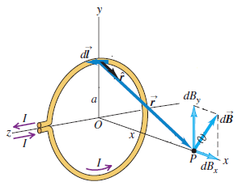Where: βP = magnetic field at a point P along the axis of the coil

N = number of turns

*I* = current in the coil

*a* = radius of the coil

r = distance from the point P to the radius of coil

Note: At the center of the coil (r=a), $β_{P}= \frac{μ_{0}}{2}∙\frac{NI}{a}=2πx{10}^{-7}\frac{NI}{a}$

1. **MAGNETIC FIELD due to a SOLENOID**

A long coil of wire consisting of many loops is called a solenoid and each loop produces a magnetic field. Between any two wires, the fields due to each loop tend to cancel. Toward the center of the solenoid, the fields add up to give a field that can be fairly large and fairly uniform.

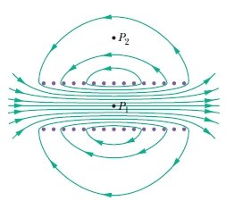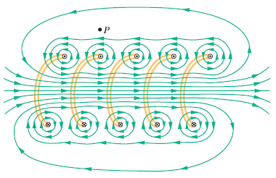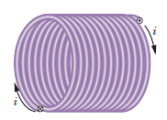

Let “P” be any point along the axis of solenoid

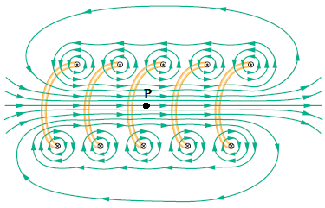

**θ1  θ2**

***L***

Where: βP = magnetic field at a point P along the axis of the solenoid

N = number of turns

*I* = current in the solenoid

L = length of the solenoid

SAMPLE PROBLEMS:

1. A +6µC point charge is moving at a constant speed of 8x106 m/s in the +y-direction, relative to a reference frame. At the instant when the point charge is at the origin of this reference frame, what is the magnetic-field it produces at point with coordinates x=0.5m and y=0.5m?
2. A pair of point charges, q1 = 5µC and q2 = -3µC are moving in a reference frame as shown. At this instant, what are the magnitude and direction of the net magnetic field produced at the origin? v1 = 6x105 m/s and v2 = 8x105 m/s.

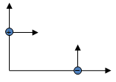

0.3m

0.4m

q1

q2

v1

v2

O

1. Two infinitely long wires carrying 12A and 8A in opposite directions are laid parallel in air 10 cm apart. Find the resultant magnetic field at a point

“c”

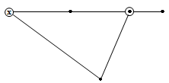

“b”

5cm

5cm

2cm

8cm

10cm

I1 = 12A

I2 = 8A

“a”

1. midway between the wires.
2. 2cm from 8A and 12cm from 12A.
3. 8cm from 8A and 10cm from 12A.
4. A coil consisting of 25 turns has a radius of 20cm and carries a current of 8 Amp. Determine the magnetic field at (a) its center and (b) a point on its axis 10cm from its center. Draw a diagram to indicate the current and the magnetic field. (The coil is along the x-z plane whose current is moving from the z to the x-axis.)
5. In the figure, solve for the resultant magnetic field at point “O”.

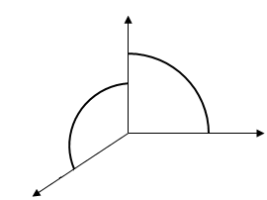

x

y

z

coil 2

coil 1

O

Coil 1: I1 = 2A

N1 = 30 turns

a1 =

Coil 2: I2 = 4A

N2 = 25 turns

A2 =

1. A solenoid is positioned with its axis on the y-axis as shown. The current I = 10 A and its radius is 0.1m. It has 100 turns. Solve for the flux density at point “O”.

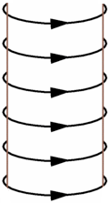

x

z

y

O

0.2m

0.3m

0.1m